SQL DOCUMENTATION

C00296913 - Reanielle Broas

CREATE USERS

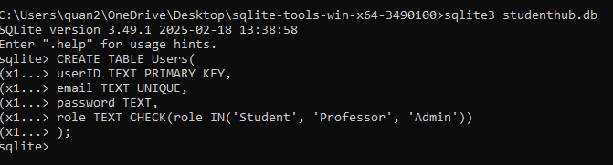

CREATE COURSES

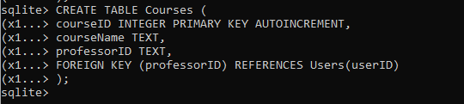

CREATE GRADES

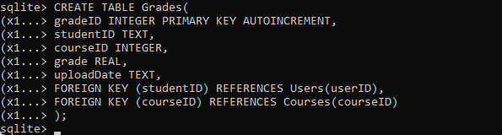

CREATE NOTES

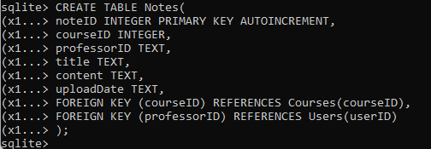

CREATE TIMETABLE

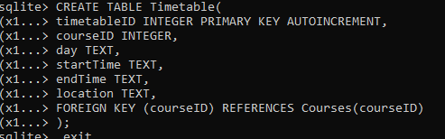

Everything:

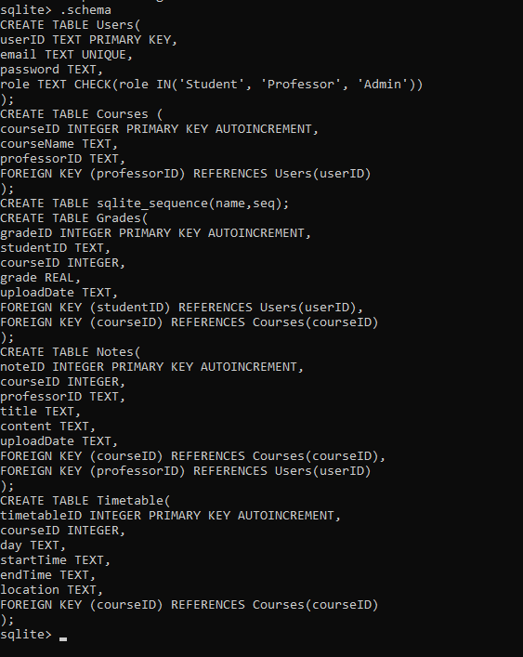

INSERTING TEST DATA

